# Launcher Icons

Launcher Icons are the icons which will represent your application when installed on your phone.

Google recommendations about the development of launcher icons can be found [here](https://developer.android.com/guide/practices/ui_guidelines/icon_design_launcher.html).

Setting a launcher icon in an application is easy.

**Designer**

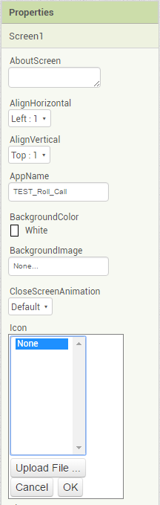

In the properties page, click on the Icon field and select Upload File.